|  |  |
| --- | --- |
|  |  |

VITTORIA

**Dante Network Bridge**

**PRODUCT DETAILS**

|  |  |
| --- | --- |
|  |  |
| **6 BROOKS PLACE, MAIDSTONE, KENT, ME14 1HE. ENGLAND** | **TEL: +44 (0) 1622 753662** |
| **Visit our Website at www.glensound.com** | **FAX: +44 (0) 1622 762330** |

|  |  |
| --- | --- |
|  | Glensound Electronics Ltd |

Thank you for choosing a new Glensound product.

All rights reserved.

Information contained in this manual is subject to change without notice, if in doubt please contact us for the latest product information.

If you need any help with the product then we can be contacted at:

Glensound Electronics Ltd  
1 – 6 Brooks Place  
Maidstone  
Kent  
ME14 1HE  
United Kingdom

Telephone: +44 (0) 1622 753662

Fax: +44 (0) 1622 762330

EMAIL ADDRESSES

General enquires: office@glensound.co.uk

Technical enquires: techinfo@glensound.co.uk

Sales enquires: sales@glensound.co.uk

# IMPORTANT SAFETY INSTRUCTIONS



1. Read these instructions
2. Keep these instructions
3. Heed all warnings
4. Follow all instructions
5. Do not use this apparatus near water
6. Clean only with a dry cloth
7. Do not block any ventilation openings. Install in accordance with manufacturer’s instructions
8. Do not install near any heat sources such as radiators, heat registers, stoves, or other apparatus (including amplifiers) that produce heat
9. Do not defeat the safety purpose of the polarized or grounding type plug. A polarized plug has 2 blades with one wider than the other. A grounding type plug has 2 blades and third grounding prong. The wider blade or the 3rd prong are provided for your safety. If the provided plug does not fit into your outlet, consult an electrician for replacement of the obsolete outlet
10. Protect the power cord from being walked on or pinched, particularly at plugs, convenience receptacles and the point where they exit from the apparatus
11. Only use attachments/ accessories specified/ supplied by the manufacturer
12. Use only with the cart, stand, tripod, bracket, or table specified by the manufacturer, or sold with the apparatus. When a cart is used, use caution when moving the cart/ apparatus combination to avoid injury from tip over
13. Unplug this apparatus during lightning storms or when unused for long periods of time
14. Refer all servicing to qualified service personnel. Servicing is required when the apparatus has been damaged in any way, such as power supply cord or plug is damaged, liquid has been spilled or objects have fallen into the apparatus, the apparatus has been exposed to rain or moisture, does not operate normally, or has been dropped
15. Do not attempt to modify this product. Doing so could result in personal injury and/ or product failure

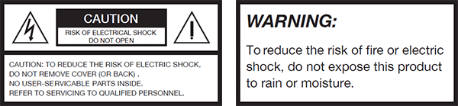

**PRODUCT WARRANTY**

All equipment is fully tested before dispatch and carefully designed to provide you with trouble free use for many years.

We have a policy of supporting products for as long as possible and guarantee to be able to support your product for a minimum of 10 years.

For a period of one year after the goods have been despatched the Company will guarantee the goods against any defect developing after proper use providing such defects arise solely from faulty materials or workmanship and that the Customer shall return the goods to the Company’s works or their local dealer.

All non-wear parts are guaranteed for 2 years after despatch and any defect developing after proper use from faulty materials or workmanship will be repaired under this warranty providing the Customer returns the goods to the Company's works or their local dealer.

CE

# EU DECLARATION OF CONFORMITY

**VITTORIA  
Dante Network Bridge**

This declaration of conformity is issued under the sole responsibility of the manufacturer.

This equipment is manufactured by Glensound Electronics Ltd of Brooks Place Maidstone Kent ME14 1HE is CE marked and conforms to the following Union harmonisation legislation:

Emissions: BS EN55032:2015

Immunity: BS EN55035:2017

Signed for and on behalf of Glensound Electronics Ltd.

Marc Wilson, Managing Director  
Maidstone, Kent, England

Date: 14/12/2021

# RoHS DIRECTIVE

RoHS 2 Directive 2011/65/EU restricts the use of the hazardous substances listed below in electrical and electronic equipment.

This product conforms to the above directive and for these purposes, the maximum concentration values of the restricted substances by weight in homogenous materials are:

|  |  |
| --- | --- |
| Lead | 0.1% |
| Mercury | 0.1% |
| Hexavalent Chromium | 0.1% |
| Polybrominated Biphenyls | 0.1% |
| Polybrominated Diphenyl Ethers | 0.1% |
| Cadmium | 0.01% |

# WASTE ELECTRICAL AND ELECTRONIC EQUIPMENT REGULATIONS 2006 (WEEE)

Glensound Electronics Ltd is registered for business to business sales of WEEE in the UK our registration number is:

WEE/JJ0074UR

**GLENSOUND VITTORIA**

# HANDBOOK CONTENTS

Description Issue 1 Page No.

Contents

IMPORTANT SAFETY INSTRUCTIONS 3

EU DECLARATION OF CONFORMITY 5

RoHS DIRECTIVE 6

WASTE ELECTRICAL AND ELECTRONIC EQUIPMENT REGULATIONS 2006 (WEEE) 7

HANDBOOK CONTENTS 8

OVERVIEW 9

VITTORIA FRONT PANEL LAYOUT 10

VITTORIA REAR PANEL LAYOUT 11

VITTORIA BLOCK DIAGRAM 12

Running Dante Controller 12

# OVERVIEW

The VITTORIA is designed to allow up to 32 bidirectional audio channels to pass between two Dante networks that are running asynchronously. Data is sample rate converted between the two networks using high quality sample rate converters.

Dante interface A is called VITR-xxx in Dante controller and is the interface on the right of the unit when viewed from the front. This interface supports sample rates between 48kHz and 192kHz. When running at 176.4 or 192kHz only 16 channels are supported.

Dante interface B is called VITL-xxx in Dante controller and is the interface on the left of the unit when viewed from the front. This interface supports sample rates between 48kHz and 192kHz. When running at 176.4 or 192kHz only 16 channels are supported.

The rear panel has two BNC connectors for each Dante interface to allow synchronization to external equipment.

# VITTORIA FRONT PANEL LAYOUT

Overview

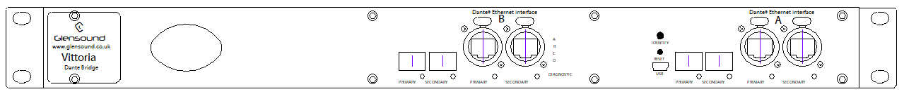

Network Area

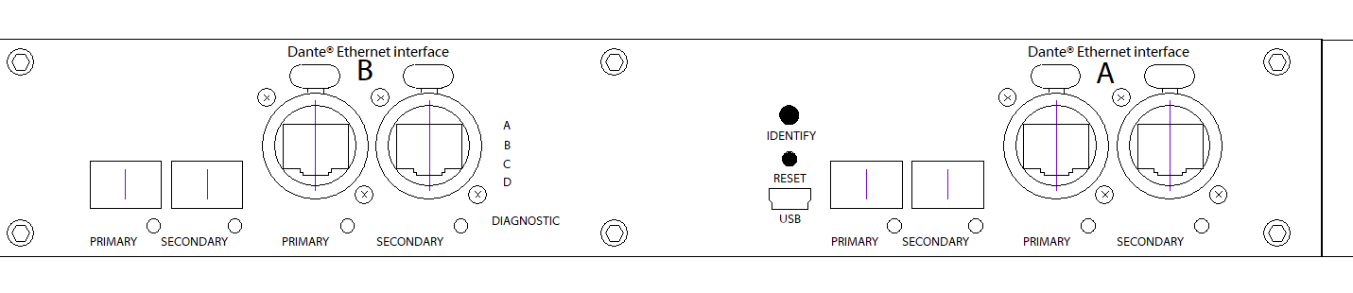

Dante interface B is located on the left, the control interface in the centre, and Dante interface A is on the right.

Both Dante interfaces support redundant operation and have RJ45 connectors for Gigabit copper Ethernet, and SFP module slots for Gigabit fibre Ethernet.

# VITTORIA REAR PANEL LAYOUT

Overview



Word Clock interface



Each Dante interface has a word clock input and a word clock output BNC connect. When an external word clock is connected to the input it allows the Dante network to be synchronized to this device. Note that this must be enabled in Dante controller. Only one device on the network should have sync to external enabled.

The word clock output follows the Dante network sample rate.

Mains inputs



The VITTORIA has two mains inlets for redundant power supplies.

# VITTORIA BLOCK DIAGRAM

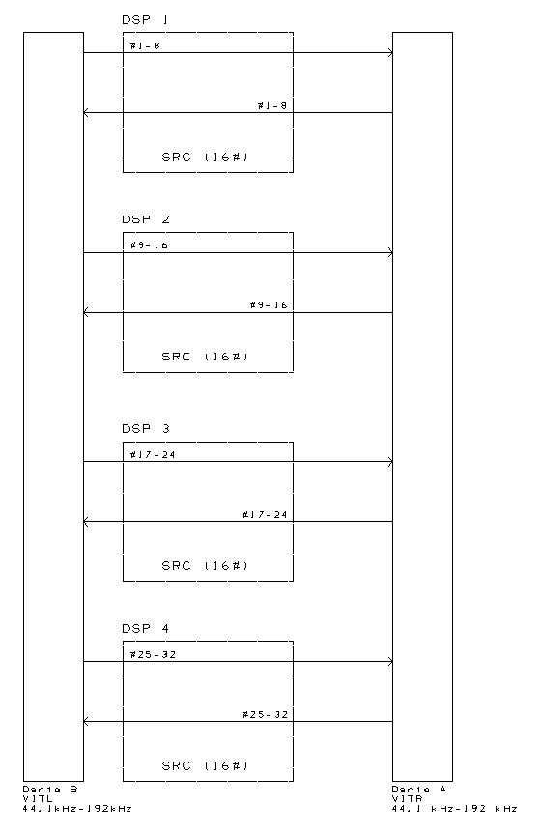

## Running Dante Controller

At the time of writing this manual the Dante Controller looks as per the screenshot below:

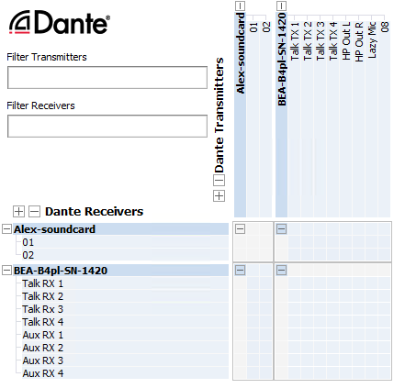

The VITTORIA will have been named at the factory during test to allow them to be identified by the Dante controller.

The format used for the factory name is:

‘VITL-SN-XXXX’ for interface B (on the left) and

‘VITR-SN-XXXX’ for interface A (on the right)

The ‘SN-XXXX’ refers to the serial number of the VITTORIA which can be found printed on the rear of the unit.

The unit may be renamed in Dante controller by opening the ‘Device view’ window and selecting VITx… in the drop-down menu. Go to the ‘Device Config’ tab and change the name with the Rename Device box.